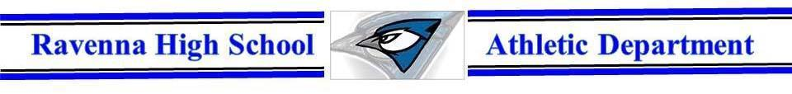

Operational Zone “Orange”
Attendance for Spectators | -Masks are required to enter & leave the facility. Disposable masks will be for sale if needed.  -Wear masks when seated and not able to social distance.  -Wear masks when moving about the facility(concession, restroom, etc.)  -Children are ask to sit with their families
Seating at Games | Volleyball-Home fans on the south side  -Visiting fans on the north side  Football-Home fans on the north side  -Visiting fans on the south side
Seating for Teams | Volleyball-Home team on the west bench  -Visiting team on the east bench  Football-Home team on the north bench  -Visiting team on the south bench
Concession Stand | -Open as normal with limited items possible  -Workers will wear masks and gloves  -Social distance as much as possible  -Workers will have designated jobs
Restrooms | -Open as normal with wearing a mask and social distancing
Locker Rooms | -Available if wanted for both volleyball & football
Cheerleaders | -Allowed in both volleyball & football. In volleyball a mask is needed the entire time. In football masks are required to get in then up to the opposing school if they wear them on the sideline.
Student Section | -Ravenna students must wear masks and maintain social distancing as much as possible.
Water Fountain | -Water bottle container filling only
We will have games available online. Go to our home page“www.ravennabluejays.org” the live stream is at the bottom of the page.
Goal: These guidelines give all student-athletes the best possible opportunity to compete this year. We are committed to student involvement in activities, and giving them the opportunity to participate is an important part of their education. We are excited for our students to have these opportunities and want to alleviate as many situations where students need to miss opportunities due to quarantining or illness. Thank you for helping to support our students.

